1. Go to window start

Search for notepad application

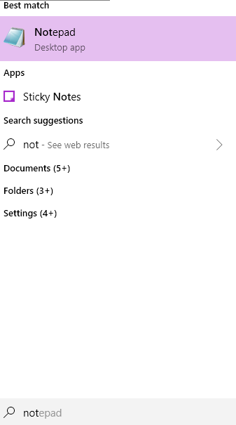

Right click on notepad

Open Notepad as an administrator

Then open file in the notepad as given below:

Please click File

Click on Open

C:\Windows\System32\drivers\etc\hosts

Once open, you will see like following:

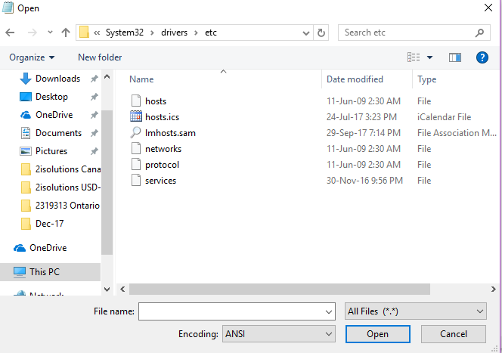

Screen clipping taken: 11-Jan-18, 9:21 PM

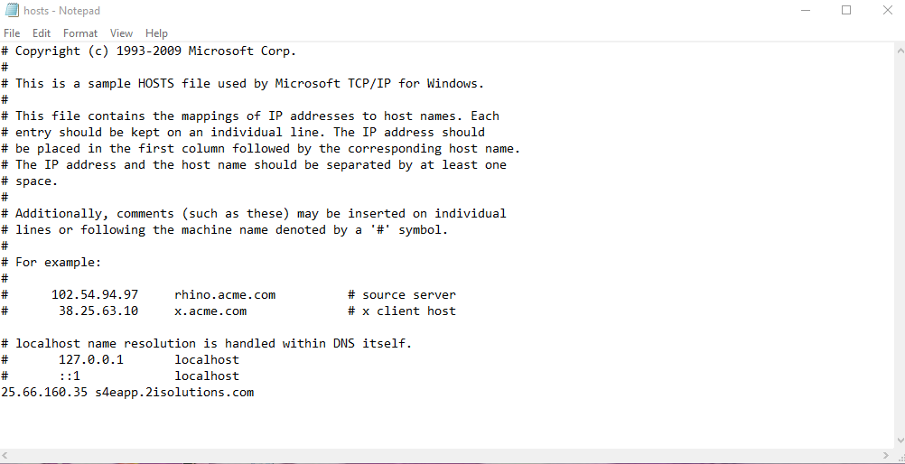

Above you added the following line:

25.66.160.35 s4eapp.2isolutions.com

Click file and save it.

If you have any issue, please contact on IIBS Office Saturday and Sunday.

|  |  |
| --- | --- |
| |  | | --- | |  | |

https://s4eapp.2isolutions.com:44300/sap/bc/ui5_ui5/ui2/ushell/shells/abap/FioriLaunchpad.html?sap-client=100

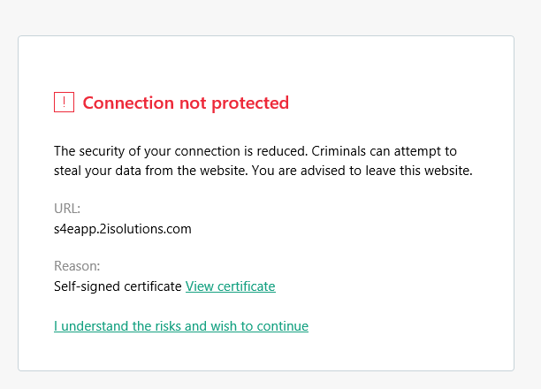

Please click for continue for access Fiori link

**User Id: same as SAP user id**

**Password: same as use to SAP logon**